JAVA COLLECTION

DOCUMENTATION

DATE : 29-02-2024

HIMANSHU KAKKAR

* WHAT IS JAVA COLLECTION?

Java Collection, also known as the Java Collections Framework (JCF), is a set of interfaces and classes in Java that provides a standardized architecture for representing and manipulating groups of objects. It offers a comprehensive suite of data structures and algorithms to handle collections of objects efficiently.

The Java Collections Framework provides a comprehensive set of classes and interfaces for working with collections of objects in Java. Let's delve into the details of Java Collections:

1. **Interfaces**:
   * **Collection**: The root interface in the Java Collections Framework. It represents a group of objects known as elements. Subinterfaces include List, Set, Queue, and Deque.
   * **List**: An ordered collection (sequence) that allows duplicate elements. Subinterfaces include ListIterator and RandomAccess.
   * **Set**: A collection that contains no duplicate elements. Subinterfaces include SortedSet and NavigableSet.
   * **Queue**: A collection used for holding elements before processing. Subinterfaces include BlockingQueue and TransferQueue.
   * **Deque**: A double-ended queue that supports insertion and removal of elements at both ends. Subinterfaces include BlockingDeque.
2. **Classes**:
   * **ArrayList**: Implements List interface using a dynamically resizable array.
   * **LinkedList**: Implements List interface using a doubly-linked list.
   * **HashSet**: Implements Set interface using a hash table for storage.
   * **TreeSet**: Implements Set interface using a red-black tree for storage.
   * **HashMap**: Implements Map interface using a hash table for key-value mappings.
   * **TreeMap**: Implements Map interface using a red-black tree for key-value mappings.
3. **Utility Classes**:
   * **Collections**: Contains static methods for working with collections, such as sorting, searching, and synchronization.
   * **Arrays**: Contains static methods for working with arrays, such as sorting, searching, and converting between arrays and collections.
4. **Features**:
   * **Generics**: Java Collections Framework uses generics to provide type safety and reduce the risk of runtime errors.
   * **Iterators**: All collection classes implement the Iterable interface, allowing them to be iterated using enhanced for loop or iterators.
   * **Concurrency**: Some collection classes (e.g., ConcurrentHashMap, ConcurrentSkipListMap) provide support for concurrent access.\
   * **Sorting and Searching**: Collections class provides utility methods for sorting and searching elements in collections.
   * **Null Values**: Most collection classes allow null values, except TreeMap and TreeSet.
5. **Performance Characteristics**:
   * Different collection classes have different performance characteristics for various operations such as insertion, deletion, and lookup. For example, ArrayList provides constant-time positional access but slower insertion and removal.
   * Choosing the appropriate collection class depends on factors like data size, frequency of operations, and memory overhead.
6. **Best Practices**:
   * Use interfaces as reference types to allow flexibility in changing the underlying implementation.
   * Use generics to ensure type safety and avoid casting.
   * Be aware of the performance characteristics of different collection classes and choose the appropriate one based on the specific requirements of your application.
   * Prefer the use of enhanced for loop over iterators for traversing collections whenever possible.

Understanding Java Collections Framework is essential for Java developers as it provides a powerful and flexible way to work with collections of objects, offering various data structures and operations to suit different needs and scenarios.

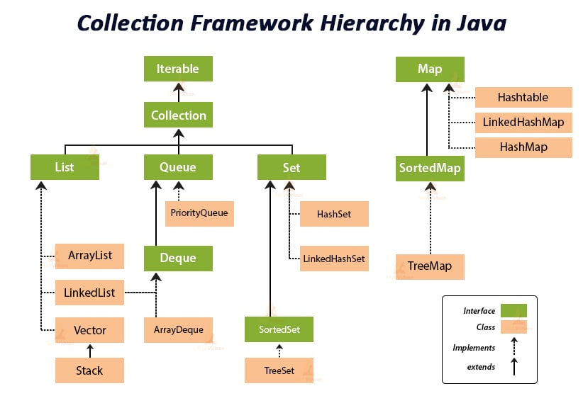

Thank You